SCHOOLOFCOMPUTER SCIENCE AND ARTIFICIAL INTELLIGENCE |  |  |  |  | DEPARTMENTOFCOMPUTER SCIENCE ENGINEERING
ProgramName:B. Tech |  |  |  | AssignmentType: Lab |  |  | AcademicYear:2025-2026
CourseCoordinatorName |  |  |  | Venkataramana Veeramsetty
Instructor(s)Name |  |  |  | Dr. V. Venkataramana (Co-ordinator)  Dr. T. Sampath Kumar  Dr. Pramoda Patro  Dr. Brij Kishor Tiwari  Dr.J.Ravichander  Dr. Mohammand Ali Shaik  Dr. Anirodh Kumar  Mr. S.Naresh Kumar  Dr. RAJESH VELPULA  Mr. Kundhan Kumar  Ms. Ch.Rajitha  Mr. M Prakash  Mr. B.Raju  Intern 1 (Dharma teja)  Intern 2 (Sai Prasad)  Intern 3 (Sowmya)  NS_2 ( Mounika)
CourseCode |  |  | 24CS002PC215 | CourseTitle |  | AI Assisted Coding
Year/Sem |  |  | II/I | Regulation |  | R24
DateandDay  of Assignment |  |  | Week5 - WednesDay | Time(s)
Duration |  |  | 2 Hours | Applicableto  Batches
AssignmentNumber:10.1(Presentassignmentnumber)/24(Totalnumberofassignments)
 | Q.No. | Question |  |  |  |  |  | ExpectedTime  to complete
 | 1 | Lab 10 – Code Review and Quality: Using AI to Improve Code Quality and Readability  Lab Objectives  - Use AI for automated code review and quality enhancement.  - Identify and fix syntax, logical, performance, and security issues in Python code.  - Improve readability and maintainability through structured refactoring and comments.  - Apply prompt engineering for targeted improvements.  - Evaluate AI-generated suggestions against PEP 8 standards and software engineering best practices  Task Description #1 – Refactor Nested Conditionals  Task: Provide AI with the following nested conditional code and ask it to simplify and refactor for readability.  Python script.  def discount(price, category):  if category == "student":  if price > 1000:  return price * 0.9  else:  return price * 0.95  else:  if price > 2000:  return price * 0.85  else:  return price  Expected Output:  - Refactored code using cleaner logic, possibly a dictionary or separate helper functions.  Task Description #2 – Optimize Redundant Loops  Task: Give AI this messy loop and ask it to refactor and optimize.  Python script  def find_common(a, b):  res = []  for i in a:  for j in b:  if i == j:  res.append(i)  return res  Expected Output:  Cleaner version using Python sets (set(a) & set(b))  Task Description #3 – Improve Class Design  Task: Provide this class with poor readability and ask AI to improve:  - Naming conventions  - Encapsulation  - Readability & maintainability  Python Script  class emp:  def __init__(self,n,s):  self.n=n  self.s=s  def inc(self,p):  self.s=self.s+(self.s*p/100)  def pr(self):  print("emp:",self.n,"salary:",self.s)  Expected Output:  - Employee class with meaningful methods (increase_salary, display_info), formatted output, and added docstrings.  Task Description #4 – Modularize Long Function  Task: Give AI this long unstructured function and let it modularize into smaller helper functions.  Python Script  def process_scores(scores):  total = 0  for s in scores:  total += s  avg = total / len(scores)  highest = scores[0]  for s in scores:  if s > highest:  highest = s  lowest = scores[0]  for s in scores:  if s < lowest:  lowest = s  print("Average:", avg)  print("Highest:", highest)  print("Lowest:", lowest)  Expected Output:  - Split into functions: calculate_average, find_highest, find_lowest.  - Clean main process_scores() using helper functions.  Task Description #5 – Code Review on Error Handling  Task: Provide AI with this faulty code and ask it to improve error handling, naming, and readability.  Python Script  def div(a,b):  return a/b  print(div(10,0))  Expected Output:  - Function with proper error handling using try-except.  - Better naming (divide_numbers).  - AI-generated docstring explaining error handling.  Task Description #6 – Complexity Reduction  Task: Use AI to simplify overly complex logic.  Sample Input Code:  def grade(score):  if score >= 90:  return "A"  else:  if score >= 80:  return "B"  else:  if score >= 70:  return "C"  else:  if score >= 60:  return "D"  else:  return "F"  Expected Output:  - Cleaner logic using elif or dictionary mapping. |  |  |  |  |  | Week5 - Monday

Task Description #1 – Refactor Nested Conditionals
Task: Provide AI with the following nested conditional code and ask it to simplify and refactor for readability.

Python script.
def discount(price, category):
if category == "student":
if price > 1000:
return price * 0.9
else:
return price * 0.95
else:
if price > 2000:
return price * 0.85
else:
return price

Expected Output:
- Refactored code using cleaner logic, possibly a dictionary or separate helper functions.

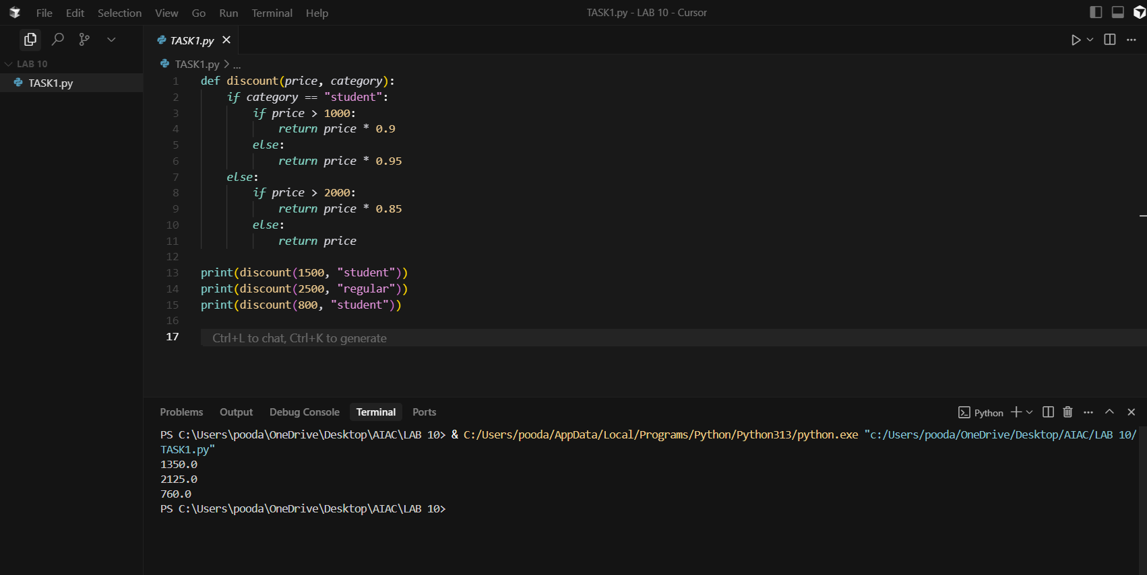

REDUCED CODE :

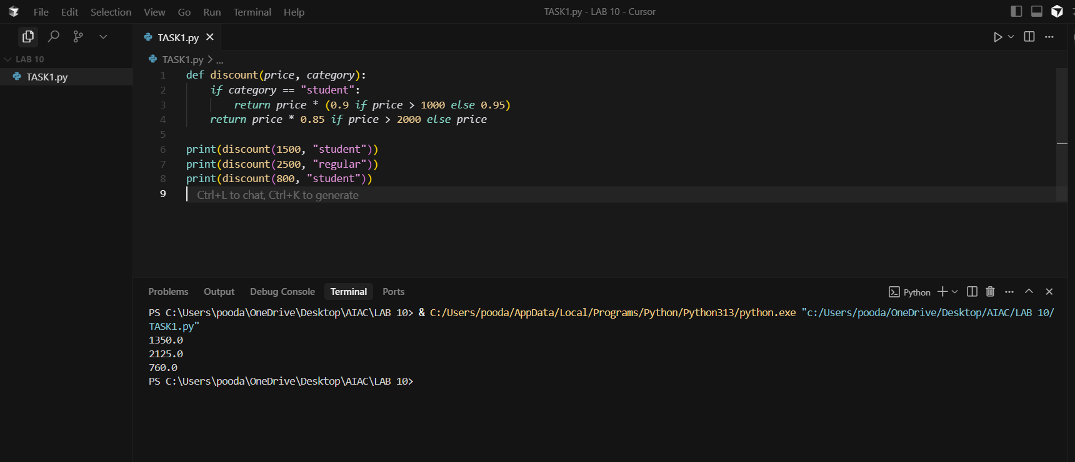

Task Description #2 – Optimize Redundant Loops
Task: Give AI this messy loop and ask it to refactor and optimize.

Python script
def find_common(a, b):
res = []
for i in a:
for j in b:
if i == j:
res.append(i)
return res

Expected Output:
Cleaner version using Python sets (set(a) & set(b))

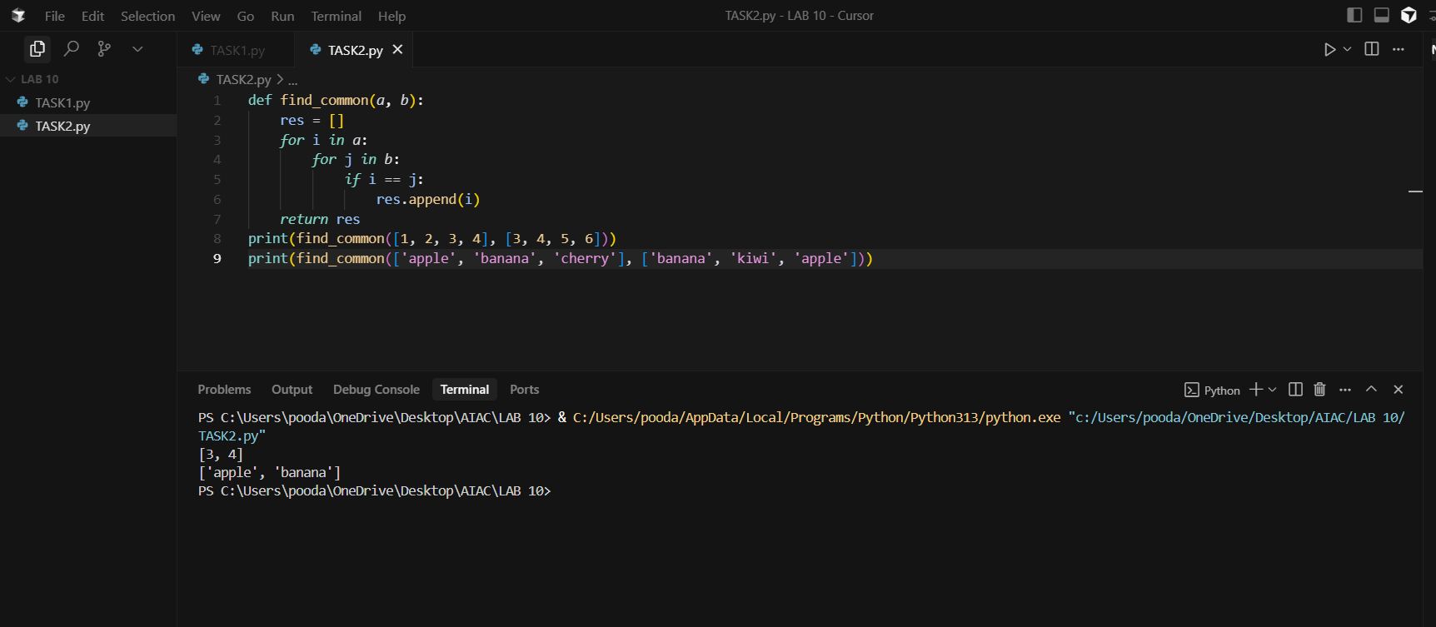

REDUCED CODE :

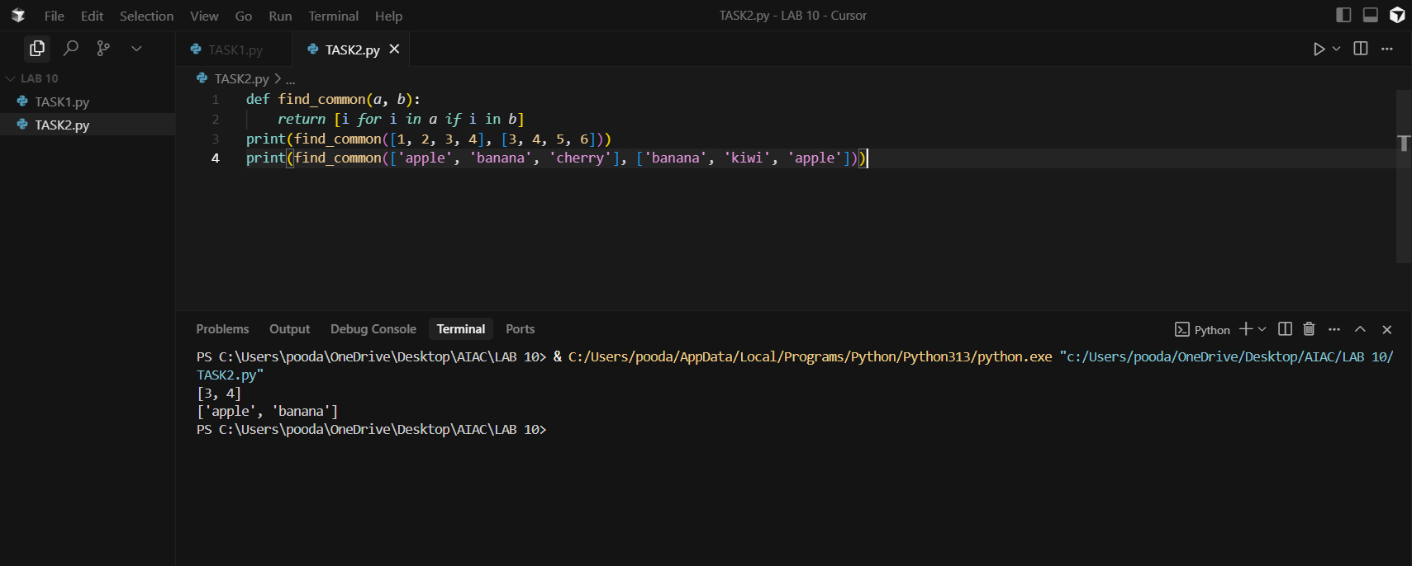

Task Description #3 – Improve Class Design

Task: Provide this class with poor readability and ask AI to improve:
- Naming conventions
Encapsulation
- Readability & maintainability
Python Script
class emp:
def __init__(self,n,s):
self.n=n
self.s=s
def inc(self,p):
self.s=self.s+(self.s*p/100)
def pr(self):
print("emp:",self.n,"salary:",self.s)

Expected Output:
- Employee class with meaningful methods (increase_salary, display_info), formatted output, and added docstrings.

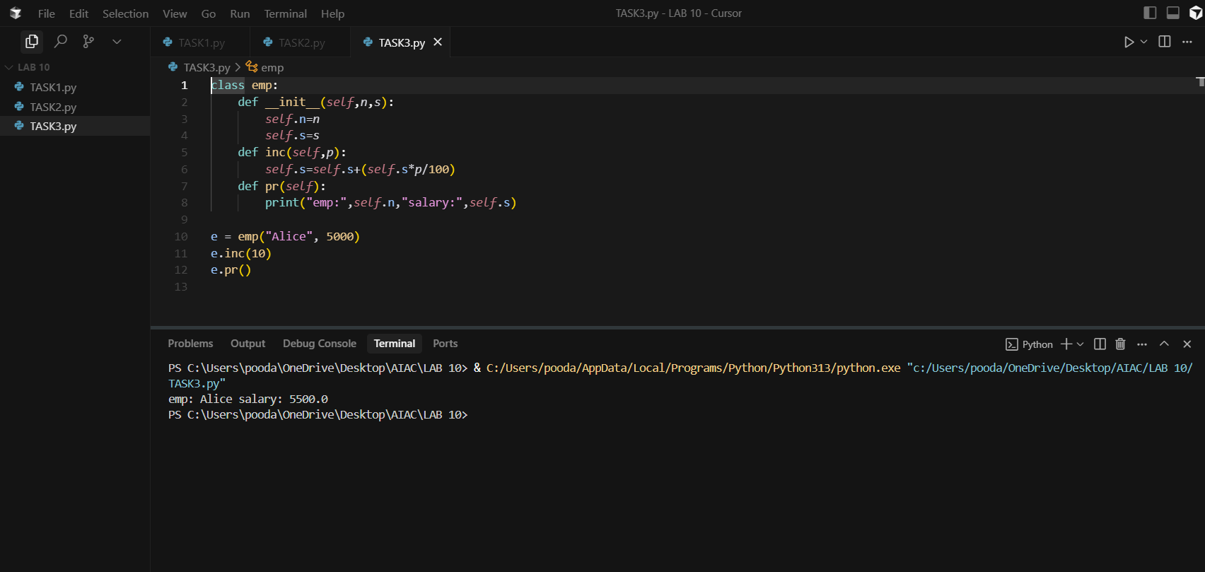

REDUCED CODE :

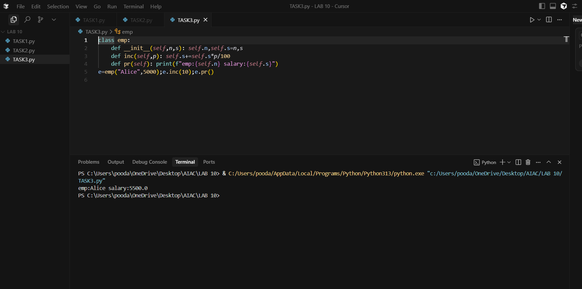

Task Description #4 – Modularize Long Function
Task: Give AI this long unstructured function and let it modularize into smaller helper functions.
Python Script
def process_scores(scores):
total = 0
for s in scores:
total += s
avg = total / len(scores)

highest = scores[0]
for s in scores:
if s > highest:
highest = s

lowest = scores[0]
for s in scores:
if s < lowest:
lowest = s

print("Average:", avg)
print("Highest:", highest)
print("Lowest:", lowest)

Expected Output:
- Split into functions: calculate_average, find_highest, find_lowest.
Clean main process_scores() using helper functions.

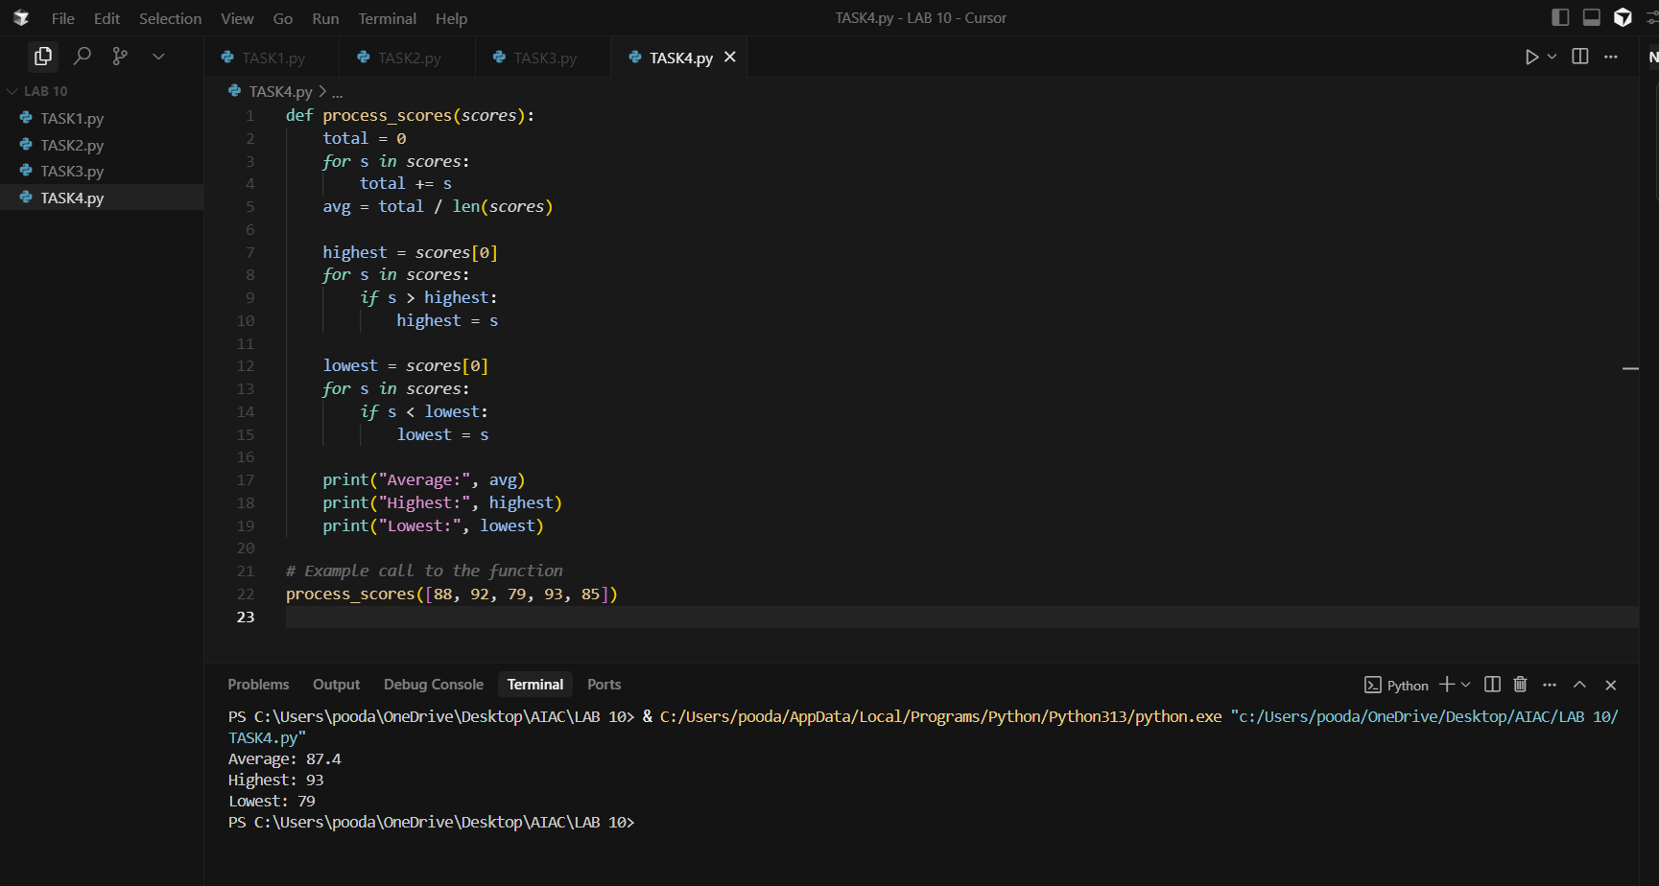

REDUCED CODE :

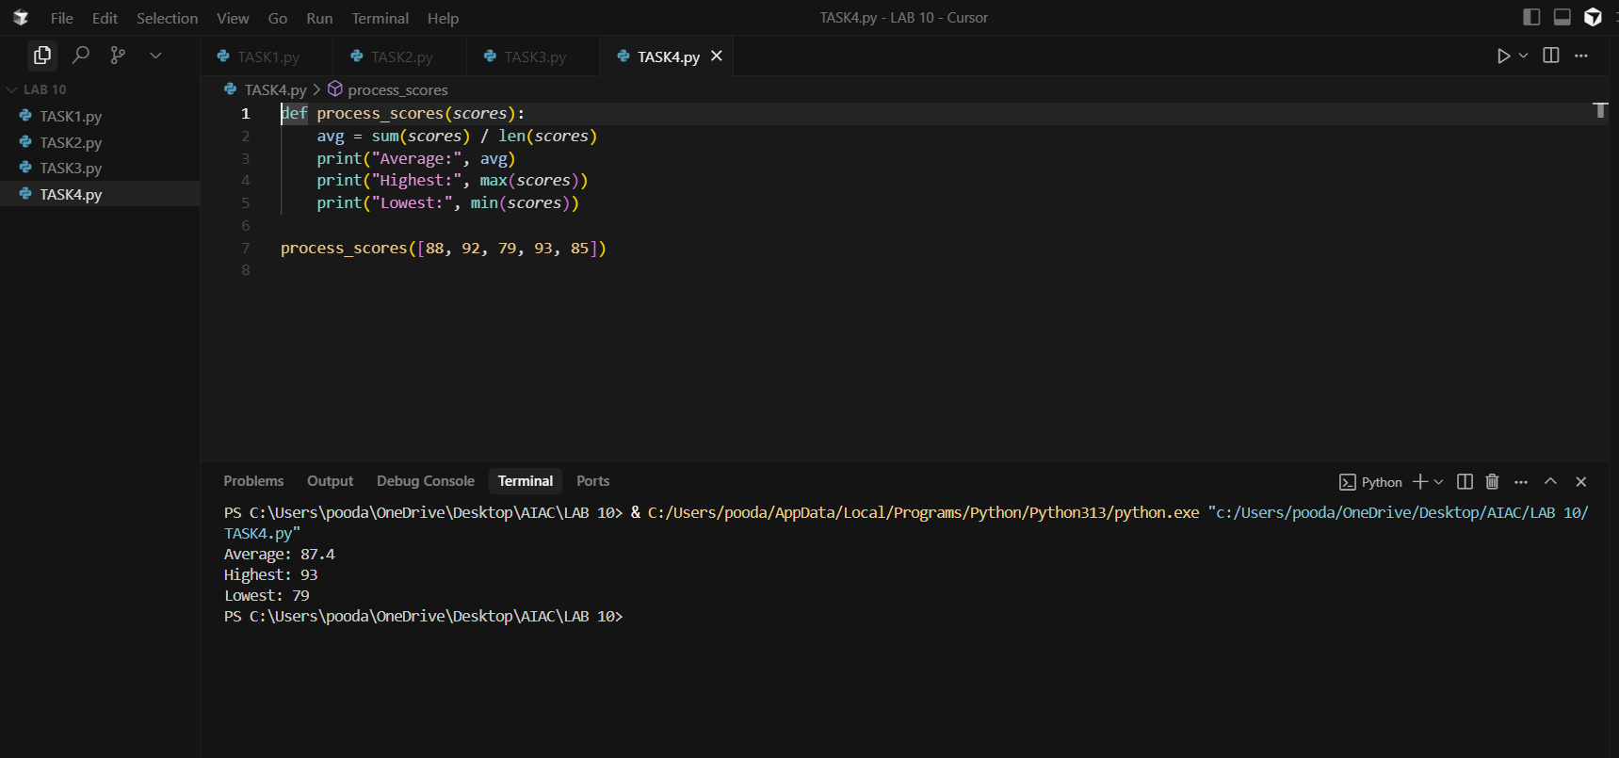

Task Description #5 – Code Review on Error Handling
Task: Provide AI with this faulty code and ask it to improve error handling, naming, and readability.

Python Script
def div(a,b):
return a/b
print(div(10,0))

Expected Output:
- Function with proper error handling using try-except.
- Better naming (divide_numbers).
- AI-generated docstring explaining error handling.
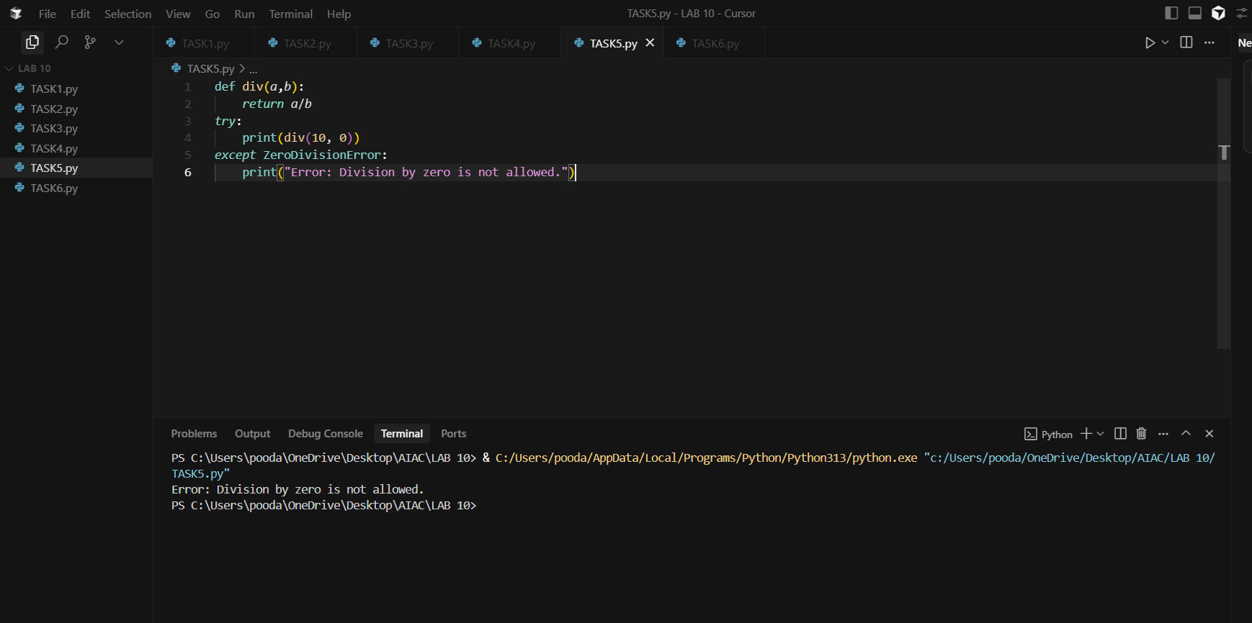

REDUCED CODE :

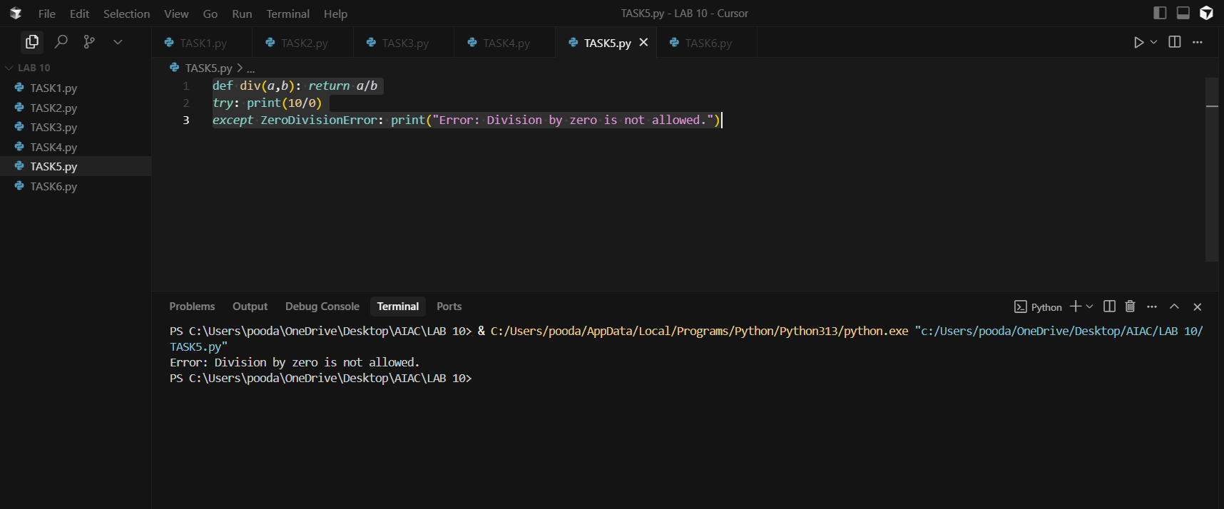

Task Description #6 – Complexity Reduction
Task: Use AI to simplify overly complex logic.
Sample Input Code:
def grade(score):
if score >= 90:
return "A"
else:
if score >= 80:
return "B"
else:
if score >= 70:
return "C"
else:
if score >= 60:
return "D"
else:
return "F"
Expected Output:
- Cleaner logic using elif or dictionary mapping.

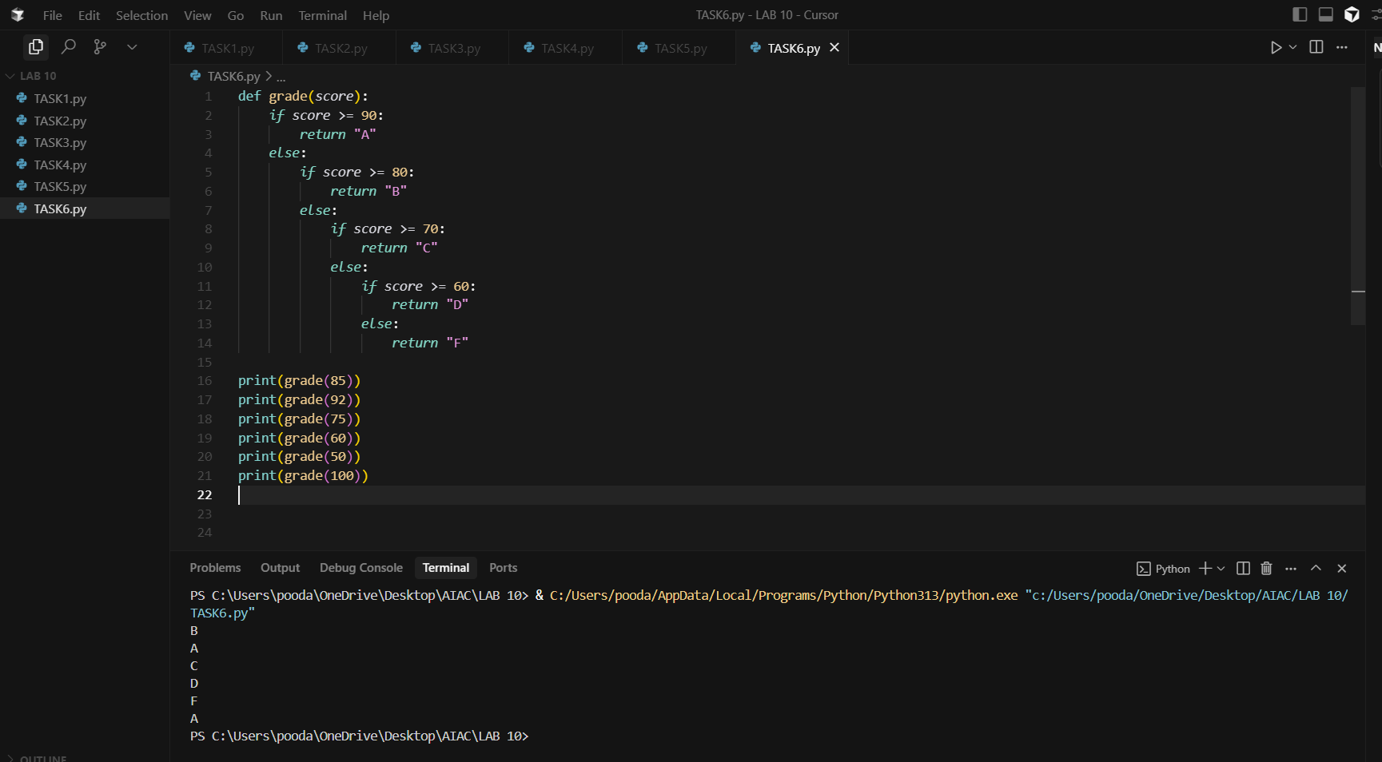

REDUCED CODE :

